**Methodology/Principle behind the problem**

The main principle involved in predicting the stability of iron and its oxide in an environment of Hydrogen ($H_{2}$) and Water ($H_{2}O$) is based on **Gibb’s Free Energy** and the **spontaneity** of the reaction.

At constant **temperature** and **pressure**, the change in Gibbs free energy is defined as $∆G= ∆H-T∆S$.

$$∆G:The Gibb^{'}s free energy of the reaction$$

$$∆H: The change in enthalpy of the reaction$$

$$∆S:The change in entropy of the reaction$$

$$T:Temperature in K \left(Kelvin\right)$$

When $∆G<0$, the reaction is spontaneous in the **forward** reaction and when $∆G>0$, the reaction is spontaneous in the **backward** direction.

Our calculations were based on these expressions,

$$aA\left(s\right)+bB\left(g\right)↔cC\left(s\right)+dD(g)$$

$$∆G= ∆G°+RTln(\frac{{P_{D}}^{d}}{{P_{B}}^{b}})$$

$$P_{D}+ P_{B}=1$$

$$∆G= ∆G°+RTln(\frac{{P_{D}}^{d}}{{{(1-P}_{D})}^{b}})$$

$$P_{D}= \frac{1}{e^{\frac{-∆G°}{bRT}}+1 }$$

$$∆G=0 at equilibrium \& b=d (for our question)$$

**Plots and explanation**

The above expression was used to plot the graphs at various temperatures for all the three reactions. (Please refer to the pdf submitted for more detailed working.)

|  |  |
| --- | --- |
|  |  |
| $$FeO+H_{2}→Fe+H_{2}O$$ | ΔG° = *259600 - 62.55T* *J/mol* |
| $${Fe}_{3}O_{4}+{4H}_{2}→3Fe+4H_{2}O$$ | ΔG° = *1091000 - 312.80T* *J/mol* |
| $${Fe}_{3}O_{4}+{4H}_{2}→3Fe+4H_{2}O$$ | ΔG° = *312200 – 125.15T* *J/mol* |
| $4FeO→ {Fe}_{3}O_{4}+Fe$ | ΔG°=-52600+62.6T J/mol |

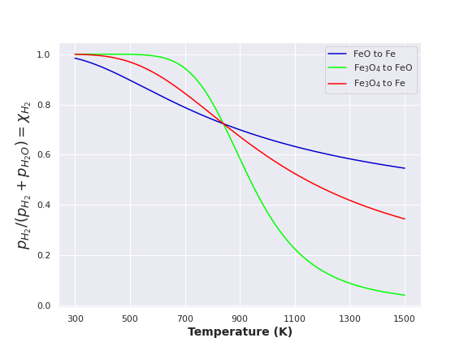

**Stability regions\***

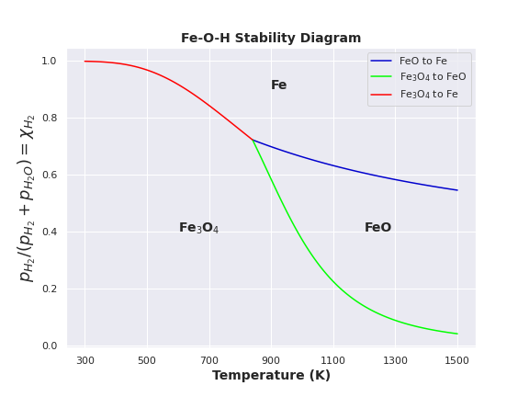

The above plot removes some of the lines from the previous plot. The point of intersection comes out to be 840.25K (52600/62.6) with $X_{H_{2}}$ =0.7233, the intersection represents the **triple point** and the point where $Fe, FeO \& {Fe}_{3}O_{4}$ are in **equilibrium** with one another and hence $∆G=0$ so ΔG°=0 as Keq = 1 as all reactants are solid, so T_eqm = 52600/62.6 = 840.25 K

Above 840.25K, according to the Gibb’s Free energy equation, the reaction

$4FeO→{Fe}_{3}O_{4}+ Fe$

will be spontaneous in the backward direction as ΔG>0. Hence, whenever ${Fe \& Fe}_{3}O_{4}$ are present together, they’ll combine together to form $FeO$. Therefore, the line corresponding to ${Fe-Fe}_{3}O_{4}$ equilibrium will be absent after 840.25K.

Below 840.25K, according to Gibb’s Free energy equation, the reaction

$4FeO→{Fe}_{3}O_{4}+ Fe$

will be spontaneous in the forward direction as ΔG<0. Hence, $FeO$ always decomposes to form ${Fe \& Fe}_{3}O_{4}$. Thus, the lines containing $FeO$ will be absent below 840.25K.

**Source**

All Thermodynamic Data was taken from MM209 Assignment 4 Question numbers 2 and 3 (Autumn 2020). (The base data used is given in the pdf file submitted)

**Contribution**

The problem was discussed among us and solved cumulatively. The report was prepared and drafted equally by us three.

**Anagh Purkar (200110012)**: - The python Code for FeO-Fe and the calculation of thermodynamic data related to it.

**Chaitanya Kadam (200110053)**: - The python Code for Fe3O4-Fe and the calculation of thermodynamic data related to it.

**Dipanshu Gayakwad (200110033)**: - The python Code for Fe3O4-FeO and the calculation of thermodynamic data related to it.

**\***We’ve **submitted two files for our code**, a **.py** file and a **.ipynb** file, the .py file can be run in any Python environment (preferably PyCharm), the .ipynb file is an **Interactive Python Notebook** which shows the code in a report format.